UML Diagrams for nPr and nCr functions

Behavioural:

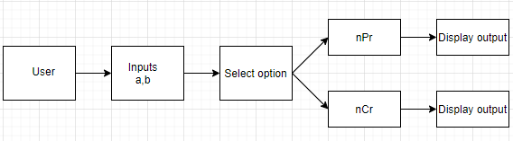

Structural:

